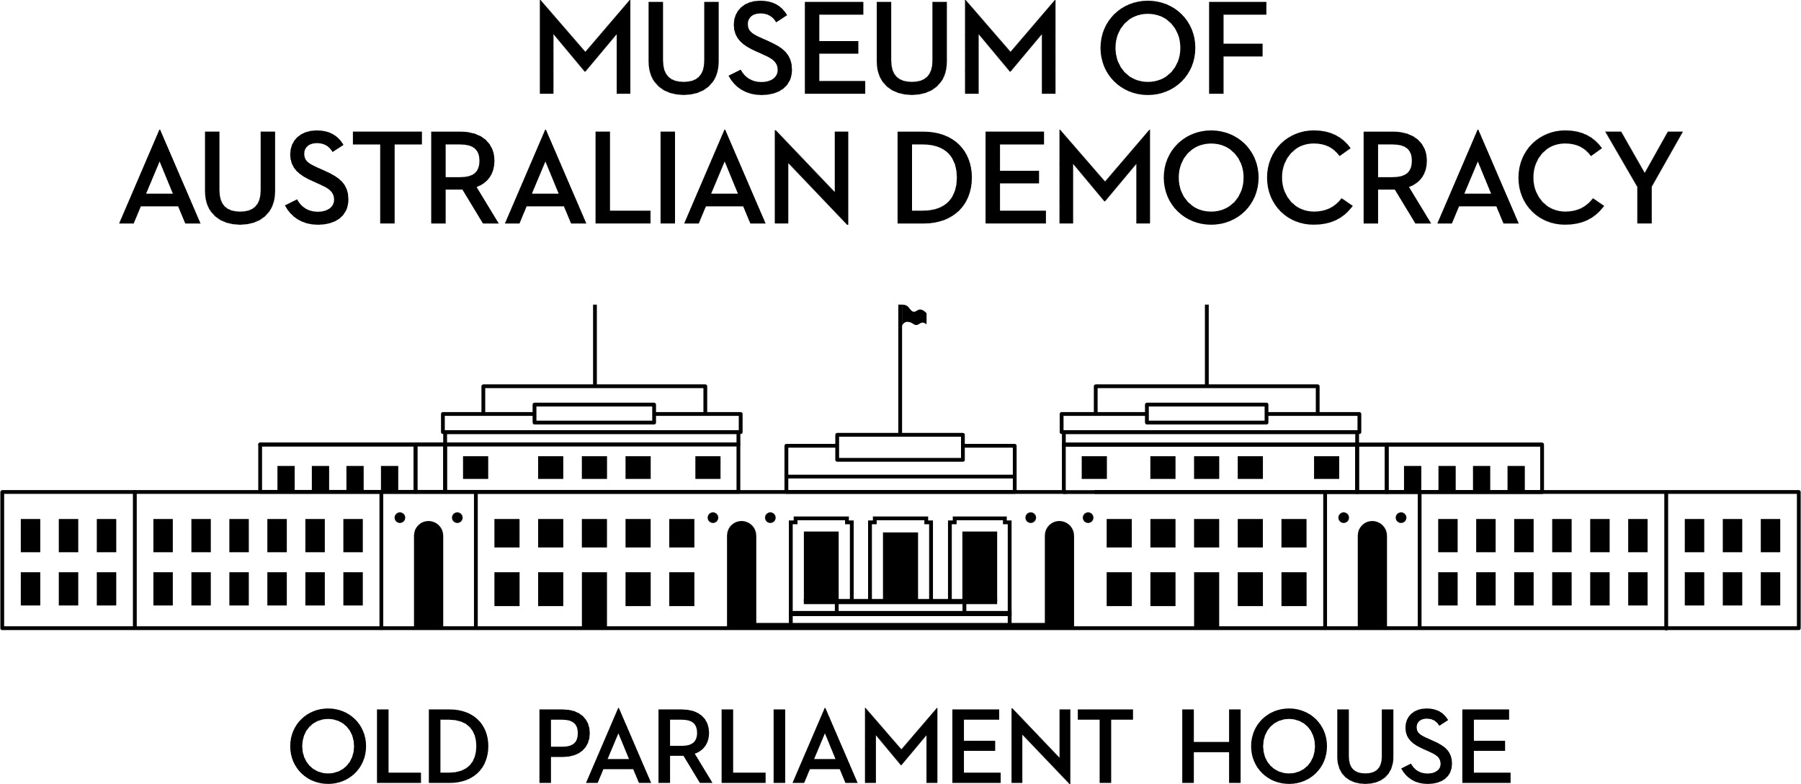

**CANDIDATE PACK**

|  |  |
| --- | --- |
|  | |
| **POSITION DETAILS** | |
| **REFERENCE NO** | Several Positions |
| **TITLE** | Assistant Curator – Affirmative Measures |
| **CLASSIFICATION** | APS level 4 (1 position), APS level 5 (1 position) |
| **EMPLOYMENT TYPE** | Non-Ongoing Specified Task |
| **WORKING HOURS** | Full-time/Part time |
| **OFFICE ARRANGEMENT** | On-site with work from home considered |
| **SALARY** | APS 4 $75,385 – $81,775 pa +15.4% Superannuation  APS 5 $84,229 – $91,808 pa +15.4% Superannuation |
| **SECTION** | Curatorial and Interpretation |
| **TEAM** | Research, Collections and Curatorial |
| **ELIGIBILITY** | * This vacancy is only available to Aboriginal and/or Torres Strait Islander people * Australian Citizenship * Baseline Security Clearance (after commencement) |
| **CONTACT OFFICER** | Ashley Tenison  02 6270 8148 |
| **OPENING DATE** | Friday 8 August 2025 |
| **CLOSING DATE** | Monday 8 September 2025 11:59 pm |
| **SPECIAL NOTE** | **Affirmative measures**  The filling of this vacancy is intended to constitute an affirmative measure under section 8(1) of the 'Racial Discrimination Act 1975'. This vacancy is only available to Aboriginal and/or Torres Strait people. This initiative/program is only applicable where the successful applicant will be employed under the Public Service Act 1999. Similar conditions may apply when employed under other Acts. For clarification please contact the agency. |
|  | **These are non-ongoing Specified Task opportunities until the end of the centenary program in late 2027.**  Suitable candidates may be placed in a merit pool from this selection process and the pool may be used to fill similar non-ongoing roles. Non-ongoing vacancies filled from a merit pool may be offered as a specified task. |

**ABOUT US**

The Museum of Australian Democracy (MoAD) at Old Parliament House is a contemporary museum located in a heritage-listed building that was home to Australia's Parliament from 1927 to 1988.

True to our building’s original brief, we provide a ‘people’s place’, where big ideas are explored.

We share the story of Australia's democracy through exhibitions, events and education programs, as well as through our rich online collection of stories, objects and resources.

At MoAD, we celebrate the Australian democratic journey. We seek to provoke thought and inspire conversation by sharing stories and objects that played a part in shaping the nation as it is today.

Careers at MoAD are varied, from human resource officers, exhibition curators, heritage officers and learning facilitators, to digital producers, finance officers and IT specialists. We are a small agency, working in a dynamic environment, sharing our democratic and political history in a heritage-listed building.

MoAD is an inclusive and rewarding workplace that values the contributions of all our staff. We encourage applications from First Nations Australians, people with a disability, culturally and linguistically diverse people and LGBTQIA+ people. We are committed to a safe and supportive workplace which includes flexible working practices. MoAD’s commitment to reconciliation is expressed in the [MoAD Reconciliation Action Plan 2023-25](https://www.moadoph.gov.au/sites/default/files/2023-06/MoAD%20INNOVATE%20RAP_2023.pdf).

MoAD employees are engaged under the [*Public Service Act 1999*](https://www.legislation.gov.au/C2004A00538/latest/text) and are subject to the terms and conditions of employment in the [*OPH Enterprise Agreem**ent 2024-2027*](https://moadoph.gov.au/sites/default/files/2024-04/oph-enterprise-agreement-2024-2027.pdf)*.*

**POSITION DETAILS**

Old Parliament House will mark its centenary in 2027 and MoAD is developing a suite of programs for the anniversary. The Centenary program will support the sharing of First Nations’ histories and stories, in the voices of First Nations peoples, as they relate to Australian democracy.

As an Assistant Curator you’ll work in a small team of curatorial staff under the guidance of the Senior Curator, Centenary Projects. You’ll know how to research and tell a great story. You will be skilled at working with people from all walks of life. You’ll have an aptitude for exhibition and curatorial work, and be organised and proficient at administration.

**ROLE RESPONSIBILITIES and DUTIES**

**APS 4 Assistant Curator (1 position)**

With support from the Senior Curator, the APS 4 Curatorial Assistant will:

* Carry out focused research using MoAD’s collection, materials from other institutions, and input from stakeholders, including the general public.
* Assess the provenance, cultural context and significance of objects that might be featured in MoAD exhibitions or added to the collection.
* Work collaboratively with internal teams and external contacts and professionally represent MoAD.
* Support curatorial work through excellent record keeping including updating database information, organising research materials, managing object lists, and keeping track of stakeholders.
* With support from senior staff, write and review exhibition content and other materials for onsite and online visitors.

A**PS 5 Assistant Curator (1 position)**

Working under limited direction from the Senior Curator, the APS 5 Curatorial Assistant will:

* Develop and deliver exhibition and interpretive content for onsite and online visitors.
* Carry out focused research using MoAD’s collection, materials from other institutions, and input from stakeholders, including the general public.
* Assess the provenance, cultural context and significance of objects that might be featured in MoAD exhibitions or added to the collection.
* Work collaboratively with internal teams and external contacts and professionally represent MoAD.
* Represent MoAD at a range of public forums and in the print, radio, television and online media.

**OUR IDEAL CANDIDATE**

The ideal candidates for these positions are storytellers who enjoy working with people, objects and settings to create engaging experiences for onsite and online museum visitors.

The qualities that we are seeking for each position are outlined below:

**APS4 Assistant Curator**

* Demonstrated research skills in Australian history, museum studies, or a related discipline.
* Knowledge and interest in Australian political, social, and democratic history.
* Excellent organisational skills, an ability to set and manage priorities, and flexibility. An ability to complete tasks in a timely and thorough manner.
* Demonstrated and well-developed communication skills.
* Demonstrated ability to work in a team and with different types of stakeholders.
* Ability to use a range of applications including standard ICT tools – including Microsoft Word and Microsoft Outlook – and an ability and willingness to learn new software.

* A basic working knowledge of KE EMu database would be an advantage.

**APS5 Assistant Curator**

* Tertiary qualifications and a strong interest in Australian social, political and democratic history, museum studies, or a related discipline are highly desirable.

* Excellent organisational skills and an ability to set and manage priorities, and complete tasks in a timely and thorough manner.
* Demonstrated and well-developed communication skills.
* Demonstrated ability to work in a team and with different types of stakeholders.
* Ability to think creatively to solve problems, to be flexible in your approach and to deliver high quality work.

* Ability to support and provide advice and guidance to less experienced colleagues as required.

* Ability to use a range of applications including standard ICT tools – including Microsoft Word and Microsoft Outlook – and an ability and willingness to learn new software.

**YOUR APPLICATION**

Please provide a:

* concise statement of claims of no more than 2 pages. When framing your statement, please ensure you adequately demonstrate your skills, qualifications, experience and capabilities.
* Resume outlining your career history, qualifications and contact details for at least two recent referees (no more than 4 pages).
* coversheet from the [MoAD Website](https://www.moadoph.gov.au/about/careers). Please note: when you complete the coversheet please indicate which role/s you are applying for.

MoAD accommodates requests for reasonable adjustment for people with disabilities to participate in an interview, including offering onsite tours to potential employees before their interviews to gauge any possible access barriers and to comfortably see staff spaces before committing to interview or the job position. Please indicate this in your cover sheet or contact the recruitment officer on 02 6270 8235 or 02 6270 8127.

**ELIGIBILITY**

To be eligible for this position at MoAD, applicants must:

* + be an Australian Citizen; and
  + be Aboriginal and/or Torres Strait Islander and provide evidence of Aboriginal or Torres Strait Islander status (further detail below).
  + have a security clearance or be willing to undertake the process to obtain a baseline clearance (after commencement).
  + be willing to provide identity documents and undergo an identity pre-employment check through a Document Verification Service, if you are deemed to be the successful candidate.

**Affirmative Measures:** The filling of this vacancy is intended to constitute an affirmative measure under section 8(1) of the 'Racial Discrimination Act 1975'. This vacancy is only available to Aboriginal and/or Torres Strait Islander people Eligible applicants:

* are of Aboriginal and/or Torres Strait Islander descent; and
* identify as Aboriginal and/or Torres Strait Islander; and
* are accepted by their community as being Aboriginal and/or Torres Strait Islander.

**Confirmation of Heritage:** Evidence of Aboriginal or Torres Strait Islander status. To demonstrate eligibility for employment under this affirmative measure, you are required to provide evidence of your heritage as an Aboriginal and/or Torres Strait Islander person within your first three-months of employment. Suitable evidence of Aboriginal or Torres Strait Islander status may include:

* A letter signed by the Chairperson of an incorporated Indigenous organisation confirming that the applicant is recognised as an Aboriginal and/or Torres Strait Islander person, or
* A confirmation of Aboriginal and/or Torres Strait Islander descent document executed by an Indigenous organisation.
* Please visit [Aboriginal and Torres Strait Islander Recruitment Guide | Australian Public Service Commission (https://apsc.gov.au)](https://www.apsjobs.gov.au/s/external-link?url=https%3A%2F%2Fwww.apsc.gov.au%2Fworking-aps%2Fdiversity-and-inclusion%2Faboriginal-and-torres-strait-islander-workforce%2Faboriginal-and-torres-strait-islander-recruitment-guide%235-confirmation-of-aboriginal-andor-torres-strait-islander-heritage) for more information or contact us to discuss this process and let us know how we can support you.

**SUBMISSION OF APPLICATION**

Your application should be submitted by the closing date to [applications@moadoph.gov.au](mailto:applications@moadoph.gov.au)

For noting:

* Your application will be automatically acknowledged. If you do not receive an automated receipt, please contact 02 6270 8235 or 02 6270 8127 or email [recruitment@moadoph.gov.au](mailto:recruitment@moadoph.gov.au)
* Applications received after closing will not be accepted unless a prior arrangement has been made with the contact officer