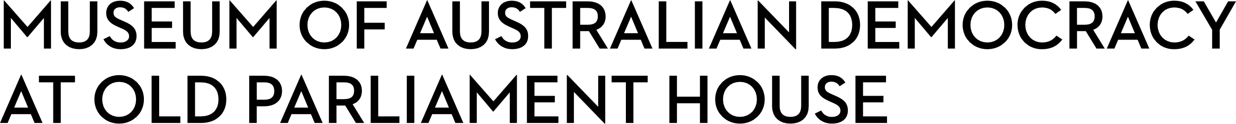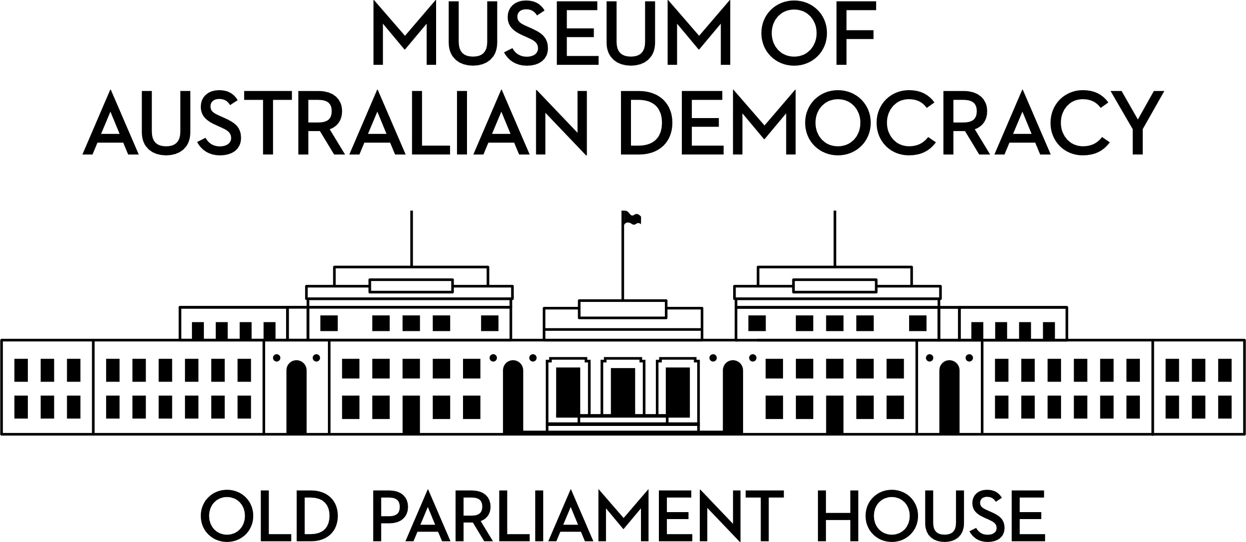

**CANDIDATE PACK**

|  |  |
| --- | --- |
|  | |
| **POSITION DETAILS** | |
| **REFERENCE NO** | 22100 |
| **TITLE** | Senior Media & Communications Coordinator |
| **CLASSIFICATION** | APS Level 6 |
| **EMPLOYMENT TYPE** | Ongoing |
| **WORKING HOURS** | Full-time |
| **OFFICE ARRANGEMENT** | On-site |
| **SALARY** | $94,563 - $105,910 + 15.4% Superannuation |
| **SECTION** | Development, Marketing, Communications & Commercial |
| **TEAM** | Marketing & Communications |
| **ELIGIBILITY** | * Australian Citizenship * Security Clearance (after commencement) |
| **CONTACT OFFICER** | Kirsty Noffke, 02 6270 8196, [kirsty.noffke@moadoph.gov.au](mailto:kirsty.noffke@moadoph.gov.au) |
| **OPENING DATE** | Wednesday 20 August 2025 |
| **CLOSING DATE** | Wednesday 3 September 2025 11:59pm |
| **SPECIAL NOTE** | This is an ongoing opportunity.  Suitable candidates may be placed in a merit pool from this selection process and the pool may be used to fill similar ongoing or non-ongoing roles. Non-ongoing vacancies filled from a merit pool may be offered as a specified term.  Applicants may have their application and assessment results shared with other Australian Public Service (APS) agencies looking to fill similar roles. |

**ABOUT US**

The Museum of Australian Democracy (MoAD) at Old Parliament House is located inside a heritage-listed building that was once home to Australia's Parliament (1927 to 1988).

True to our building’s original brief, we provide a ‘people’s place’, where big ideas are explored.

We share the story of Australia's democracy through exhibitions, events and education programs, as well as through our rich online collection of stories, objects and resources.

At MoAD, we celebrate the Australian democratic journey. We seek to provoke thought and inspire conversation by sharing stories and objects that played a part in shaping the nation as it is today.

Careers at MoAD are varied, from human resource officers, exhibition curators, heritage officers and learning facilitators, to digital producers, finance officers and IT specialists. We are a small agency, working in a dynamic environment, sharing our democratic and political history in a heritage-listed building.

MoAD is an inclusive and rewarding workplace that values the contributions of all our staff. We encourage applications from First Nations Australians, people with a disability, culturally and linguistically diverse people and LGBTQIA+ people. We are committed to a safe and supportive workplace which includes flexible working practices.

MoAD employees are engaged under the [*Public Service Act 1999*](https://www.legislation.gov.au/C2004A00538/latest/text) and are subject to the terms and conditions of employment in the [*OPH Enterprise Agreem**ent 2024-2027*](https://moadoph.gov.au/sites/default/files/2024-04/oph-enterprise-agreement-2024-2027.pdf)*.*

**POSITION DETAILS**

The APS6 Senior Media & Communications Coordinator plays a pivotal role in promoting and positioning the Museum of Australian Democracy at Old Parliament House (MoAD) to strengthen the agency’s public profile and reputation.

As part of the Marketing & Communications team, this role works closely with teams across the Museum to deliver engaging and impactful media campaigns for exhibitions, programs, and broader organisational initiatives.

The position oversees the assessment and coordination of filming requests, supports the planning and delivery of media events, and fosters strong, positive relationships with media outlets, partners, and both internal and external stakeholders.

In addition, the role contributes to and manages elements of MoAD’s corporate and internal communications.

Success in this position requires the ability to work collaboratively across multiple teams, manage competing priorities, and communicate effectively with a diverse range of stakeholders.

**ROLE RESPONSIBILITIES and DUTIES**

Under the direction of the EL1 Manager Marketing & Communications, the Senior Media & Communications Coordinator will be required to:

* Support proactive media engagement – from pitching stories and managing interviews to building strong relationships with journalists and media outlets.
* Develop and deliver creative and strategic media and communication campaigns that promote exhibitions, programs and projects, enhancing MoAD’s brand and reputation.
* Create and edit a wide range of high-quality written content, including media releases, briefing materials, talking points, and promotional communications, including MoAD’s EDM.
* Oversee and coordinate external filming requests and media activity within our heritage-listed building.
* Monitor, analyse, and report on media coverage to inform future strategies.
* Develop and manage internal communications including communications plans, content, and the Museum’s intranet.
* Support the wider team to deliver stakeholder events, including media launches (such events may involve out-of-hours work).
* Work collaboratively across the organisation, fostering strong relationships and developing a sound understanding of MoAD’s goals and strategic priorities.

**OUR IDEAL CANDIDATE**

To be successful for this role you will need to demonstrate:

* Proven experience in developing and implementing strategic media and communications campaigns, ideally in Museums and Galleries or Tourism sector/s.
* Exceptional written and verbal communication skills and a high level of attention to detail.
* Experience developing and implementing internal communication strategies.
* An understanding of media coordination for filming, press conferences and events.

* Ability to build and manage effective relationships with internal and external stakeholders, applying sound judgment and discretion.
* Track record of working autonomously and managing multiple priorities in fast-paced environments while consistently meeting deadlines.
* Experience working collaboratively with both internal and external stakeholders, to deliver shared communication and media outcomes.

**YOUR APPLICATION**

Please provide a:

* concise statement of claims of no more than 2 pages. When framing your statement, please ensure you adequately demonstrate your skills, qualifications, experience and capabilities.
* Resume outlining your career history, qualifications and contact details for at least two recent referees (no more than 2 pages).
* coversheet from the [MoAD Website](https://www.moadoph.gov.au/about/careers).

MoAD accommodates requests for reasonable adjustment for people with disabilities to participate in an interview, including offering onsite tours to potential employees before their interviews to gauge any possible access barriers and to comfortably see staff spaces before committing to interview or the job position. Please indicate this in your cover sheet or contact the recruitment officer on 02 6270 8235 or 02 6270 8127.

**ELIGIBILITY**

To be eligible for this position at MoAD, applicants must:

* be an Australian Citizen; and
* have a security clearance or be willing to undertake the process to obtain a baseline clearance (after commencement).
* be willing to provide identity documents and undergo an identity pre-employment check through a Document Verification Service, if you are deemed to be the successful candidate.

**SUBMISSION OF APPLICATION**

Your application should be submitted by the closing date to [applications@moadoph.gov.au](mailto:applications@moadoph.gov.au)

For noting:

* Your application will be automatically acknowledged. If you do not receive an automated receipt, please contact 02 6270 8235 or 02 6270 8127 or email [recruitment@moadoph.gov.au](mailto:recruitment@moadoph.gov.au)
* Applications received after closing will not be accepted unless a prior arrangement has been made with the contact officer