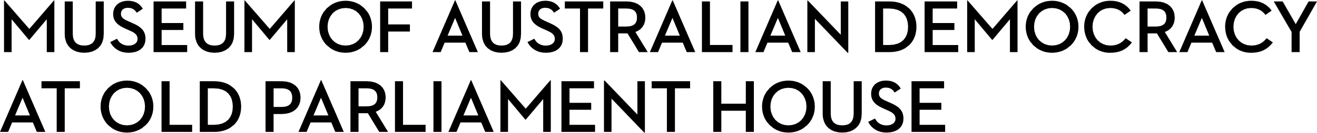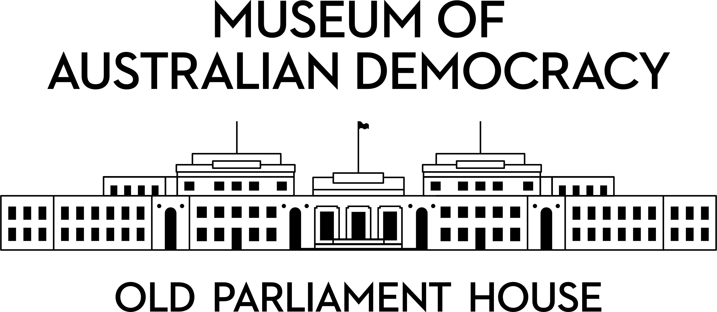

**CANDIDATE PACK**

|  |  |
| --- | --- |
|  | |
| **POSITION DETAILS** | |
| **REFERENCE NO** | 40014 |
| **TITLE** | Casual Event AV Technician |
| **CLASSIFICATION** | APS4 |
| **WORKING HOURS** | Casual |
| **OFFICE ARRANGEMENT** | On-site |
| **SALARY** | $75,385 + 15.4% Superannuation + 25% loading in lieu of public holidays and leave entitlements, except Long Service Leave. Annual salary will be paid as an hourly rate. |
| **SECTION** | Facilities, Security & Heritage |
| **TEAM** | Facilities |
| **ELIGIBILITY** | * Australian Citizenship * Security Clearance (after commencement) |
| **CONTACT OFFICER** | Allan Dantas, [Allan.Dantas@moadoph.gov.au](mailto:Allan.Dantas@moadoph.gov.au) |
| **OPENING DATE** | Thursday, 4 September 2025 |
| **CLOSING DATE** | Sunday, 21 September 2025, 11:59pm |
| **SPECIAL NOTE** | MoAD seeks to establish a pool of skilled Event AV Technicians. The work is of a casual and intermittent nature, and there is no guarantee of work in any given period.  Due to the sporadic nature of events requiring AV support, applicants must have the flexibility to work weekends and evenings (sometimes at short notice). Flexible hours are frequent requirements of the position. |

**ABOUT US**

The Museum of Australian Democracy (MoAD) at Old Parliament House is located inside a heritage-listed building that was once home to Australia's Parliament (1927 to 1988).

True to our building’s original brief, we provide a ‘people’s place’, where big ideas are explored.

We share the story of Australia's democracy through exhibitions, events and education programs, as well as through our rich online collection of stories, objects and resources.

At MoAD, we celebrate the Australian democratic journey. We seek to provoke thought and inspire conversation by sharing stories and objects that played a part in shaping the nation as it is today.

Careers at MoAD are varied, from human resource officers, exhibition curators, heritage officers and learning facilitators, to digital producers, finance officers and IT specialists. We are a small agency, working in a dynamic environment, sharing our democratic and political history in a heritage-listed building.

MoAD is an inclusive and rewarding workplace that values the contributions of all our staff. We encourage applications from First Nations Australians, people with a disability, culturally and linguistically diverse people and LGBTQIA+ people. We are committed to a safe and supportive workplace which includes flexible working practices.

MoAD employees are engaged under the [*Public Service Act 1999*](https://www.legislation.gov.au/C2004A00538/latest/text) and are subject to the terms and conditions of employment in the [*OPH Enterprise Agreem*](https://moadoph.gov.au/sites/default/files/2024-04/oph-enterprise-agreement-2024-2027.pdf)*ent 2024-2027.*

**POSITION DETAILS**

Working alongside the broader MoAD and Facilities team, the casual Event AV Technician is responsible for setting up, operating, and maintaining audio-visual equipment for various onsite events. This includes onsite activities, public programs, corporate clients, and an onsite contracted catering provider. This role involves working with a wide range of AV equipment such as audio, video, lighting and live streaming equipment to ensure seamless event execution.

The Technician must have strong technical skills, attention to detail, and the ability to work under pressure. Excellent communication and problem-solving abilities are also essential, as the role often involves interacting with clients and addressing their needs promptly. The role collaborates with and is supported by broader MoAD teams and external contractors during peak event periods.

Due to the sporadic nature of events requiring AV support, applicants must have the flexibility to work weekends and evenings (sometimes at short notice). Flexible hours are frequent requirements of the position.

**ROLE RESPONSIBILITIES and DUTIES**

Under the direction of MoAD’s Events AV & Multimedia Technician you will be required to deliver these key duties:

* Equipment setup and operation: Setting up AV equipment according to event requirements, ensuring all devices are functioning correctly, and operating them during events.
* Troubleshooting: Quickly identifying and resolving any technical issues that arise during events to minimise disruptions.
* Coordination: Collaborating with event organisers, speakers, and performers to understand their AV needs and ensure all requirements are met.
* Technical Support: Providing on-site technical support and guidance to clients and staff in the lead up and during events.
* Administration: Scheduling equipment usage, event quoting, maintaining records of equipment maintenance and repairs, and capturing event data around AV use for analysis and reporting.
* Other duties as assigned.

**OUR IDEAL CANDIDATE**

Our ideal candidate will possess a blend of technical expertise, problem-solving skills, and strong interpersonal abilities.

They will be:

* Technically proficient: Expert in AV equipment with a solid background in operational event delivery.
* Event experience: Experienced in providing high-quality support throughout all event stages within a cultural institution or other setting.
* Problem-solver: Resolves technical issues efficiently to ensure smooth event experiences and proactively seeks solutions to enhance event quality on behalf of the museum.
* Adaptable: Flexibility to adapt to changing event requirements and schedules, including a keen eye for detail to identify and resolve potential problems before they escalate.
* Collaborative team player: Skilled in working within a small team, approachable, and able to offer clear and helpful advice on event AV requirements.
* Strong communicator: Able to interact with a diverse range of stakeholders, including museum staff, external clients, and contractors.
* Self-managed: Capable of setting priorities, working independently, monitoring progress, meeting deadlines, and showing initiative.

**YOUR APPLICATION**

Please provide a:

* concise statement of claims of no more than 2 pages. When framing your statement, please ensure you adequately demonstrate your skills, qualifications, experience and capabilities.
* Resume outlining your career history, qualifications and contact details for at least two recent referees (no more than 4 pages).
* coversheet from the [MoAD Website](https://www.moadoph.gov.au/about/careers).

MoAD accommodates requests for reasonable adjustment for people with disabilities to participate in an interview, including offering onsite tours to potential employees before their interviews to gauge any possible access barriers and to comfortably see staff spaces before committing to interview or the job position. Please indicate this in your cover sheet or contact the recruitment officer on 02 6270 8235 or 02 6270 8127.

**ELIGIBILITY**

To be eligible for this position at MoAD, applicants must:

* be an Australian Citizen; and
* have a security clearance or be willing to undertake the process to obtain a baseline clearance (after commencement).
* be willing to provide identity documents and undergo an identity pre-employment check through a Document Verification Service, if you are deemed to be the successful candidate.

**SUBMISSION OF APPLICATION**

Your application should be submitted by the closing date to [applications@moadoph.gov.au](mailto:applications@moadoph.gov.au)

For noting:

* Your application will be automatically acknowledged. If you do not receive an automated receipt, please contact 02 6270 8235 or 02 6270 8127 or email [recruitment@moadoph.gov.au](mailto:recruitment@moadoph.gov.au)
* Applications received after closing will not be accepted unless a prior arrangement has been made with the contact officer