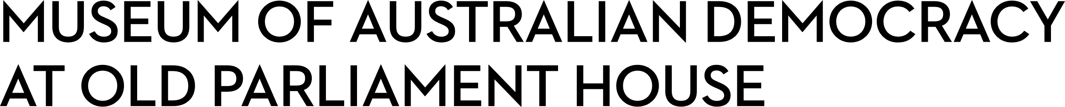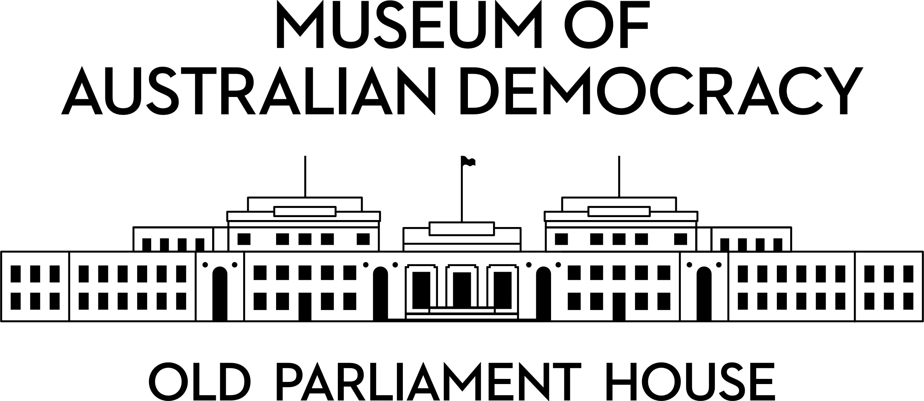

**CANDIDATE PACK**

|  |  |
| --- | --- |
|  | |
| **POSITION DETAILS** | |
| **REFERENCE NO** | 40013 |
| **TITLE** | Project & Heritage Coordinator |
| **CLASSIFICATION** | APS Level 6 |
| **EMPLOYMENT TYPE** | Non-Ongoing for a period of up to 2 years |
| **WORKING HOURS** | Full Time |
| **OFFICE ARRANGEMENT** | On site, with one day per week of work from home considered |
| **SALARY** | $94,563 - $105,910 + 15.4% Superannuation |
| **SECTION** | Capital Projects and Built Heritage |
| **TEAM** | Capital Projects and Built Heritage |
| **ELIGIBILITY** | * Australian Citizenship * Security Clearance (after commencement) |
| **CONTACT OFFICER** | Fiona Wood (02) 6270 8242 |
| **OPENING DATE** | Tuesday 2 September 2025 |
| **CLOSING DATE** | Monday 15 September 2025 (11:59pm) |
| **SPECIAL NOTE** | This is a non-ongoing opportunity for a period of up to 2 years.  Suitable candidates may be placed in a merit pool from this selection process and the pool may be used to fill similar ongoing or non-ongoing roles. Non-ongoing vacancies filled from a merit pool may be offered as a specified term.  Applicants may have their application and assessment results shared with other Australian Public Service (APS) agencies looking to fill similar roles. |

**ABOUT US**

The Museum of Australian Democracy (MoAD) at Old Parliament House is a contemporary museum located in a heritage-listed building that was home to Australia's Parliament from 1927 to 1988.

True to our building’s original brief, we provide a ‘people’s place’, where big ideas are explored.

We share the story of Australia's democracy through exhibitions, events and education programs, as well as through our rich online collection of stories, objects and resources.

At MoAD, we celebrate the Australian democratic journey. We seek to provoke thought and inspire conversation by sharing stories and objects that played a part in shaping the nation as it is today.

Careers at MoAD are varied, from human resource officers, exhibition curators, heritage officers and learning facilitators, to digital producers, finance officers and IT specialists. We are a small agency, working in a dynamic environment, sharing our democratic and political history in a heritage-listed building.

MoAD is an inclusive and rewarding workplace that values the contributions of all our staff. We encourage applications from First Nations Australians, people with a disability, culturally and linguistically diverse people and LGBTQIA+ people. We are committed to a safe and supportive workplace which includes flexible working practices. MoAD’s commitment to reconciliation is expressed in the [MoAD Reconciliation Action Plan 2023-25](https://www.moadoph.gov.au/sites/default/files/2023-06/MoAD%20INNOVATE%20RAP_2023.pdf).

MoAD employees are engaged under the [*Public Service Act 1999*](https://www.legislation.gov.au/C2004A00538/latest/text) and are subject to the terms and conditions of employment in the [*OPH Enterprise Agreem**ent 2024-2027*](https://moadoph.gov.au/sites/default/files/2024-04/oph-enterprise-agreement-2024-2027.pdf)*.*

**POSITION DETAILS**

Reporting to the Manager of Strategic Projects, the Project Coordinator will play a key role in the successful delivery of the Museum’s ongoing capital works program.

This position will be part of a small team responsible for planning and delivery of capital works, with a focus on managing major refurbishment and restoration projects and upgrading of the building infrastructure, whilst ensuring the preservation of heritage values, and compliance with the Environmental Protection and Biodiversity Conservations Act (EPBC Act), the [*Old Parliament House and Curtilage Heritage Management Plan (2021- 26)*](https://www.moadoph.gov.au/sites/default/files/2023-01/MoAD-Heritage-Management-Plan-2021-26.pdf) (HMP), and the *OPH Heritage Strategy* (OPHHS).

**ROLE RESPONSIBILITIES and DUTIES**

Under direction from the Managers of Strategic Projects and Built Heritage, and within tight deadlines, the Project Coordinator will be expected to:

* Coordinate all aspects of the day-to-day management of capital projects, including works, contractors, schedules, heritage, budget and quality control and communication.
* Develop and assist with the preparation and review of project and heritage documentation and procurement processes, to achieve project delivery while protecting heritage values.
* Assist with research for Actions Proposals and provide constructive feedback to stakeholders for final review and approval by managers.
* Review trade packages prior to tender and assess trade recommendations, seeking value for money outcomes in line with Commonwealth Procurement Rules and heritage compliance.
* Prepare reports to key management groups such as the Actions Committee, the Project Steering Committee, the MoAD Board and its Audit, Fraud and Risk Committee.
* Coordinate project budgets including cost plans, progress claims, financial spreadsheets, project expenditure, budget reconciliation, business cases and variations.
* Ensure project records are accurate, transparent and up to date and stored in accordance with MoAD’s document management systems.
* Develop, coordinate and maintain stakeholder relationships to achieve desired outcomes and prepare communications to staff and tenants on the progression of project works and to notify of works that will impact museum operations.

**OUR IDEAL CANDIDATE**

Our ideal candidate will have:

* Project and heritage management experience at the APS6 level or equivalent.
* Knowledge of issues relating to WHS, heritage and construction within occupied, heritage-listed buildings, and experience of related legislation and processes.
* Ability to prepare high quality and accurate documents and reports, with well-developed communication, presentation and interpersonal skills.
* Good stakeholder management skills and a demonstrated ability to liaise with people at a number of different levels.
* Results-oriented approach with track record for collaborative problem solving and achieving results within multi-disciplinary project teams.
* Well-developed organisation and time-management skills, with the ability to determine priorities and exercise sound judgement and initiative.
* Strong customer service and collaborative approach, with the ability to work productively across the organization to achieve the team’s objectives.
* Proficiency in the use of the MS suite of products and experience with project design and schedule documentation and management systems is desirable.

**YOUR APPLICATION**

Please provide a:

* concise statement of claims of no more than two pages. When framing your statement, please ensure you adequately demonstrate your skills, qualifications, experience and capabilities; and
* resume of no more than four pages, outlining your career history, qualifications and contact details for at least two recent referees.

MoAD accommodates requests for reasonable adjustment for people with disabilities to participate in an interview, including offering onsite tours to potential employees before their interviews to gauge any possible access barriers and to comfortably see staff spaces before committing to interview or the job position. Please indicate this in your cover sheet or contact the recruitment officer on 02 6270 8235 or

02 6270 8127.

**ELIGIBILITY**

To be eligible for this position at MoAD, applicants must:

* be an Australian Citizen;
* have a security clearance or be willing to undertake the process to obtain a baseline clearance (after commencement); and
* be willing to provide identity documents and undergo an identity pre-employment check through a Document Verification Service, if you are deemed to be the successful candidate.

**SUBMISSION OF APPLICATION**

Your application should be submitted by the closing date to [applications@moadoph.gov.au](mailto:applications@moadoph.gov.au)

For noting:

* Your application will be automatically acknowledged. If you do not receive an automated receipt, please contact 02 6270 8235 or 02 6270 8127 or email [recruitment@moadoph.gov.au](mailto:recruitment@moadoph.gov.au).
* Applications received after closing will not be accepted unless a prior arrangement has been made with the contact officer.