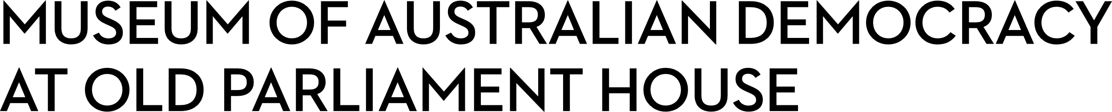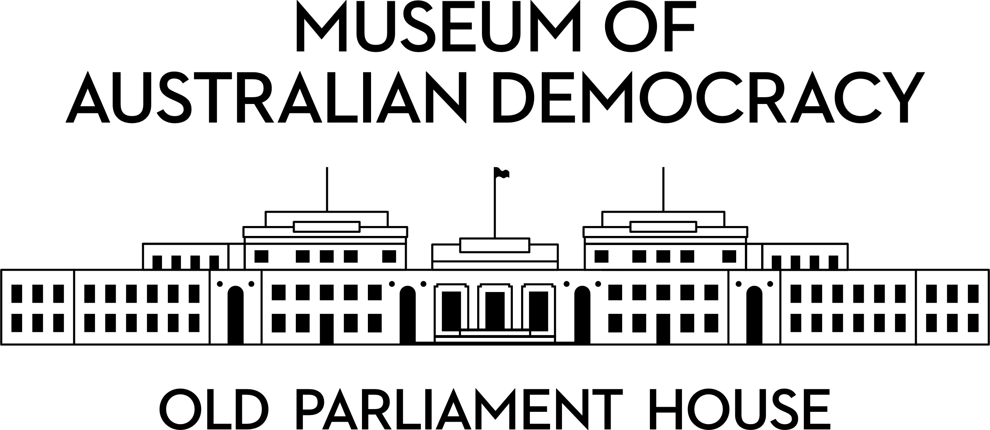

**CANDIDATE PACK**

|  |  |
| --- | --- |
|  | |
| **POSITION DETAILS** | |
| **REFERENCE NO** | Temporary Register |
| **JOB TITLES** | Learning Facilitator Museum Experience Officer Museum Engagement Facilitator |
| **CLASSIFICATION** | APS Level 3 |
| **EMPLOYMENT TYPE** | Non-Ongoing Irregular/Intermittent |
| **WORKING HOURS** | On an ‘as required’ basis. You will be paid according to timesheets submitted to the payroll team. |
| **SALARY** | $66,975 + 15.4% Superannuation + 25% loading in lieu of public holidays and leave entitlements except Long Service Leave |
| **ELIGIBILITY** | * Australian Citizenship * ACT Working with Vulnerable People registration (Prior to commencement) * Security Clearance (after commencement) |
| **CONTACT** | [Recruitment@moadoph.gov.au](mailto:Recruitment@moadoph.gov.au) |
| **OPENING DATE** | Friday 29 August 2025 |
| **CLOSING DATE** | Tuesday 30 June 2026 11:59pm |
| **NOTE** | Please note that this register is an expression of interest only and does not guarantee that an offer of employment will be made. You may be contacted if a vacancy arises that matches your skills and experience. |

**ABOUT US**

Housed in one of Australia's most prominent national heritage listed buildings, the Museum of Australian Democracy (MoAD) at Old Parliament House was the first museum in Australia dedicated to telling the story of the journey of our democracy. It seeks to provide a range of innovative exhibitions, tours, interpretation, education programs and public activities that will inspire and challenge visitors to explore democracy from its ancient roots to the present day and possible futures.  
  
These positions work under general supervision and involve engaging with our diverse audiences in a range of ways to enhance their experience at the museum.  
Common requirements for these positions include good people skills and the ability to give presentations that may involve standing for long periods of time.  
Some of these positions involve wearing a uniform.  
All positions are required to support compliance with agency security and heritage requirements.  
Successful applicants may work in one or more of the below positions, depending on your skills and experience, and the availability of shifts.

**POSITION DETAILS**

**Learning Facilitator**

The Learning team plays a key role in providing programs to over 90,000 students per year. As a member of the team, you will have excellent people skills, enjoy working with students of all ages and backgrounds, have a strong empathy for the vision and purpose of MoAD and have a sound knowledge of Australian political history and experience with working with students.

Duties:

* Present high quality education programs onsite and online.
* Ensure learning spaces and equipment are made ready for use.
* Assist with project work, as required.
* Support MoAD public programs.

**Museum Experience Officer**

The Museum Experience Team works with around 200,000 general visitors to the museum each year, from arrival to exit. The team manages our Receptions and the MoAD Shop, conducts tours, manages public enquiries online and onsite, and develops and supports other museum public programs including events.

Duties:

* Provide high quality interactions with museum visitors, including entry management, providing information to promote current museum programs, retail sales and handling telephone calls.
* Deliver and support a range of museum public programs including tours, events and facilitating activities in exhibition spaces. Occasional after-hours work may be required.
* Support and provide general direction to volunteers to ensure that their role is carried out effectively and is aligned with the museum’s objectives.
* Engage in productive working relationships that add value to service delivery

**Museum Engagement Facilitator**

The Museum Engagement Team provides award-winning experiences for visitors at MoAD. Museum Engagement Facilitators engage with adults and children to deliver a suite of informal learning experiences in a range of spaces around the museum. Families make up around one third of the museum’s general visitors. Facilitators will primarily work in the *PlayUP* exhibition developing and delivering a variety of experiences for families, as well as conduct brief research and evaluation.

Duties:

* Provide high quality engagement opportunities for museum visitors including facilitating informal learning with children and adults in the *PlayUP* exhibition and other museum spaces.
* Manage set up and pack down of craft activities, and exhibition resets as required.
* Assist with the development of new experiences including undertaking basic research and analysis

**OUR IDEAL CANDIDATE**

To be successful in these positions you will be able to demonstrate or provide evidence to support your ability to:

* Work effectively within a small team, share knowledge, show initiative and take responsibility for personal development.
* Demonstrate excellent people skills, enjoy working with visitors of all ages and have the ability to deliver and support a range of engaging public programs.
* Demonstrated strong interpersonal skills with the ability to build and maintain effective working relationships; and
* Be responsive and flexible in meeting changing priorities.

**YOUR APPLICATION**

Please fill out the Temporary Register Cover Sheet and provide an up-to-date copy of your resume.

**ELIGIBILITY**

To be eligible for this position at MoAD, applicants must:

* be an Australian Citizen; and
* have a baseline security clearance or be willing to undertake the process to obtain a baseline clearance (after commencement).
* Working with Vulnerable People – Current WwVP card
* be willing to provide identity documents and undergo an identity pre-employment check through a Document Verification Service, if you are deemed to be the successful candidate.

**SUBMISSION OF APPLICATION**

Your application should be submitted to [applications@moadoph.gov.au](mailto:applications@moadoph.gov.au)