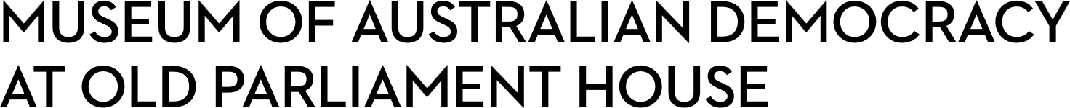
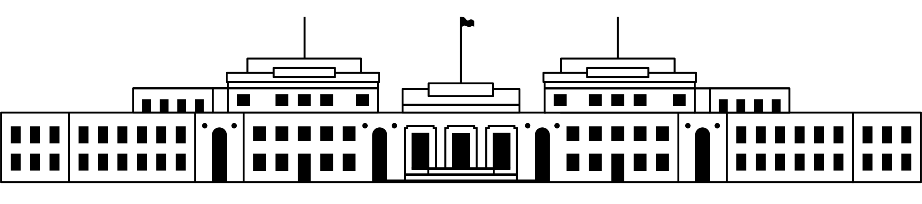

CANDIDATE PACK
POSITION DETAILS
REFERENCE NO | 34302
TITLE | Senior Development Coordinator
CLASSIFICATION | APS Level 6
EMPLOYMENT TYPE | Non-Ongoing for 6 months, with possibility of extension
WORKING HOURS | Full-time
OFFICE ARRANGEMENT | On-site
SALARY | $94,563 - $105,910 pa + 15.4% Superannuation
SECTION | Development
TEAM | Development, Marketing, Communications and Commercial
ELIGIBILITY | - Australian Citizenship  - Security Clearance (after commencement)
CONTACT OFFICER | Annalisa Millar, Head Development, Marketing, Communications and Commercial on 02 6270 8123
OPENING DATE | Monday 1 December 2025
CLOSING DATE | Sunday 14 December 2025 (11:59pm)
SPECIAL NOTES | This is a non-ongoing opportunity.  Suitable candidates may be placed in a merit pool from this selection process, and the pool may be used to fill similar non-ongoing roles. Non-ongoing vacancies filled from a merit pool may be offered as a specified term.

ABOUT US
The Museum of Australian Democracy (MoAD) at Old Parliament House is located inside a heritage-listed building that was once home to Australia's Parliament (1927 to 1988).
True to our building’s original brief, we provide a ‘people’s place’, where big ideas are explored.
We share the story of Australia's democracy through exhibitions, events and education programs, as well as through our rich online collection of stories, objects and resources.
At MoAD, we celebrate the Australian democratic journey. We seek to provoke thought and inspire conversation by sharing stories and objects that played a part in shaping the nation as it is today.
Careers at MoAD are varied, from human resource officers, exhibition curators, heritage officers and learning facilitators, to digital producers, finance officers and IT specialists. We are a small agency, working in a dynamic environment, sharing our democratic and political history in a heritage-listed building.
MoAD is an inclusive and rewarding workplace that values the contributions of all our staff. We encourage applications from First Nations Australians, people with a disability, culturally and linguistically diverse people and LGBTQIA+ people. We are committed to a safe and supportive workplace which includes flexible working practices.
MoAD employees are engaged under the Public Service Act 1999 and are subject to the terms and conditions of employment in the OPH Enterprise Agreement 2024-2027.

POSITION DETAILS

The Senior Development Coordinator position is part of a small and highly functioning team who aims to raise additional revenue for MoAD.
The Development section is a critical division of MoAD responsible for growing the organisations own-source revenue to help deliver MoAD programs, content and services to the public. The Development team has built a strong funding base with an ambitious vision in the lead up to the centenary of Old Parliament House in 2027. As a member of the Development team working in conjunction with other sections, the role includes providing broad administrative support for MoAD’s fundraising activities in-line with MoAD’s Strategic Plan.
This position will also be required to draft correspondence, liaise with internal and external stakeholders, conduct research as required and provide support for Development events.
The Development section operates within the Development, Marketing, Communications and Commercial team.

ROLE RESPONSIBILITIES and DUTIES

Reporting to the Development and Retail Manager, the Senior Development Coordinator will assist with a range of Development projects, including:
- Provide essential administrative support for all fundraising activities including annual appeals, grants and corporate partnerships
- Project support of MoAD’s 2026 Annual Appeal and other administrative support associated with the upcoming Centenary Appeal
- Be the primary manager of the CRM system by ensuring accurate upkeep of records. This will include efficient processing of a variety of donations and the ability to analyse, report and monitor data, and identify trends – informing donations reports, and mailing lists for correspondence, invitations and other needs
- Working with the Development Manager to plan, coordinate and deliver a range of donor events. This will include management of the event from inception to evaluation and working across all business units of MoAD
- Monitoring deliverables relating to corporate sponsorships and partnerships
- Researching and identifying grant opportunities as well as the completion of grant applications and acquittals
- Support the Development Managers in the preparation of key governance documents.

OUR IDEAL CANDIDATE

To be successful for this role you will need to demonstrate:

- Knowledge, understanding and experience in fundraising programs – particularly in delivering appeals.
- Good relationship-building and interpersonal skills, including the ability to consult, negotiate and liaise effectively with a diverse range of stakeholders – including prospective donors and sponsors.
- Your ability to work productively with a broad range of people from varied personal and professional backgrounds. A high level of sensitivity and professionalism is essential.
- Exceptional computer literacy and extensive experience with Microsoft Office. Experience in administering customer-relationship management (CRM) databases, using them to direct and inform philanthropic activities, will be highly desirable.
- Excellent communication skills (written and verbal) with a proven ability to work collaboratively in a team environment and with autonomy and have a strong attention to detail.
- Highly developed organisational and time-management skills, with the ability to determine priorities and achieve outcomes within tight timeframes.

YOUR APPLICATION

Please provide a:

- concise statement of claims of no more than 2 pages. When framing your statement, please ensure you adequately demonstrate your skills, qualifications, experience and capabilities.

- Resume outlining your career history, qualifications and contact details for at least two recent referees (no more than 4 pages).

- coversheet from the MoAD Website.

MoAD accommodates requests for reasonable adjustment for people with disabilities to participate in an interview, including offering onsite tours to potential employees before their interviews to gauge any possible access barriers and to comfortably see staff spaces before committing to interview or the job position. Please indicate this in your cover sheet or contact the recruitment officer on 02 6270 8235 or 02 6270 8127.

ELIGIBILITY

To be eligible for this position at MoAD, applicants must:
- be an Australian Citizen; and

- have a security clearance or be willing to undertake the process to obtain a baseline clearance (after commencement); and

- be willing to provide identity documents and undergo an identity pre-employment check through a Document Verification Service, if you are deemed to be the successful candidate.

SUBMISSION OF APPLICATION
Your application should be submitted by the closing date to applications@moadoph.gov.au

For noting:

- Your application will be automatically acknowledged. If you do not receive an automated receipt, please contact 02 6270 8235 or 02 6270 8127 or email recruitment@moadoph.gov.au

- Applications received after closing will not be accepted unless a prior arrangement has been made with the contact officer

