
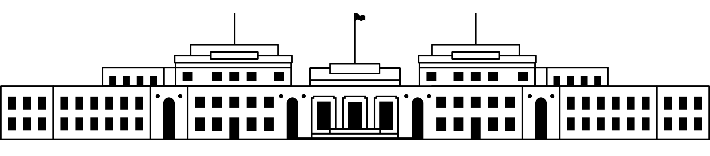

CANDIDATE PACK
POSITION DETAILS
REFERENCE NO | 21115
TITLE | Learning Facilitator
CLASSIFICATION | APS3
EMPLOYMENT TYPE | Non-Ongoing, Ongoing
WORKING HOURS | Full-time
OFFICE ARRANGEMENT | On-site
SALARY | $66,975 - $73, 185 + 15.4% Superannuation
SECTION | Learning and Museum Experience
TEAM | Learning
ELIGIBILITY | - Australian Citizenship  - Security Clearance (after commencement)  - Working with Vulnerable People card
CONTACT OFFICER | Timothy Pidkins – 02 6270 8265
OPENING DATE | Thursday 26 February 2026
CLOSING DATE | Thursday 12 March 2026 at 11:59pm
SPECIAL NOTE | This is a non-ongoing opportunity for a period of 12 months, with the possibility of ongoing.  Suitable candidates may be placed in a merit pool from this selection process and the pool may be used to fill similar ongoing or non-ongoing roles. Non-ongoing vacancies filled from a merit pool may be offered as a specified term.  Applicants may have their application and assessment results shared with other Australian Public Service (APS) agencies looking to fill similar roles.

ABOUT US
The Museum of Australian Democracy (MoAD) at Old Parliament House is located inside a heritage-listed building that was once home to Australia's Parliament (1927 to 1988).
True to our building’s original brief, we provide a ‘people’s place’, where big ideas are explored.
We share the story of Australia's democracy through exhibitions, events and education programs, as well as through our rich online collection of stories, objects and resources.
At MoAD, we celebrate the Australian democratic journey. We seek to provoke thought and inspire conversation by sharing stories and objects that played a part in shaping the nation as it is today.
Careers at MoAD are varied, from human resource officers, exhibition curators, heritage officers and learning facilitators, to digital producers, finance officers and IT specialists. We are a small agency, working in a dynamic environment, sharing our democratic and political history in a heritage-listed building.
MoAD is an inclusive and rewarding workplace that values the contributions of all our staff. We encourage applications from First Nations Australians, people with a disability, culturally and linguistically diverse people and LGBTQIA+ people. We are committed to a safe and supportive workplace which includes flexible working practices.
MoAD employees are engaged under the Public Service Act 1999 and are subject to the terms and conditions
of employment in the OPH Enterprise Agreement 2024-2027.

POSITION DETAILS
As a Learning Facilitator, you will have excellent people skills; enjoy working with a diverse team and with students of all ages; have a strong empathy for the vision and purpose of MoAD; and have a sound knowledge of Australian Political history and experience in museum education.

ROLE RESPONSIBILITIES and DUTIES

Under the general supervision of the Learning Supervisors, you will:
- Present engaging learning programs to school audiences - onsite, offsite and online, including digital excursions.

- Coordinate and maintain the operational aspects of these programs including costumes, props, AV, surveys and workshop materials.

- Assist with development, delivery and evaluation of onsite, online and digital Learning resources and programs.

- Contribute to MoAD more broadly by supporting events and attending mandatory training, project and staff meetings and role specific actions as required.

OUR IDEAL CANDIDATE

Our ideal candidate will have:
- Ability to work effectively within a small team, share knowledge and show initiative.
- Basic ICT skills as a minimum, in order to use Microsoft office suites, booking and roster systems and operational requirement for digital programs.
- Be responsive and flexible in meeting changing priorities.
- Ability to assist with the development and delivery of engaging education programs, and hands-on experiences through public speaking, interpretation and presentation skills.
- An understanding of, and interest in Australian political/social history and Aboriginal and Torres Strait Islander history and cultures, and a willingness to continue this understanding and interest.

YOUR APPLICATION
Please provide a:

- Please provide a concise statement of claims of no more than one page on how your skills and experience suit the position.

- Resume outlining your career history, qualifications and contact details for at least two recent referees (no more than 2 pages)

- coversheet from the MoAD Website.

ELIGIBILITY
To be eligible for this position at MoAD, applicants must:
- be an Australian Citizen; and

- have a security clearance or be willing to undertake the process to obtain a baseline clearance (after commencement).

- have, or be willing to undertake the process to obtain, a Working with Vulnerable People registration; and

- be willing to provide identity documents and undergo an identity pre-employment check through a Document Verification Service, if you are deemed to be the successful candidate.

SUBMISSION OF APPLICATION
Your application should be submitted by the closing date to applications@moadoph.gov.au

For noting:

- Your application will be automatically acknowledged. If you do not receive an automated receipt, please contact 02 6270 8192 or 02 6270 8235 or email recruitment@moadoph.gov.au

- Applications received after closing will not be accepted unless a prior arrangement has been made with the contact officer

