
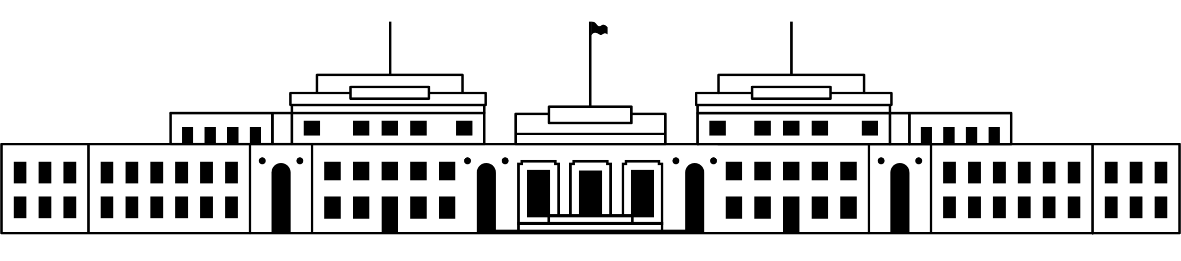

CANDIDATE PACK
POSITION DETAILS
REFERENCE NO | 21130
TITLE | Bookings and Learning Officer
CLASSIFICATION | APS 4
EMPLOYMENT TYPE | Ongoing
WORKING HOURS | Full-time
OFFICE ARRANGEMENT | On-site
SALARY | $75,385 - $81,775 pa + 15.4% Superannuation  Note: Salary range will increase to $79,125 - $86,246 pa effective 13 March 2026 as per the EA
SECTION | Museum Experience and Learning
TEAM | Learning
ELIGIBILITY | - Australian Citizenship  - Security Clearance (after commencement)
CONTACT OFFICER | Meg Shakeshaft 02 6270 8160
OPENING DATE | 23 February 2026
CLOSING DATE | 9 March 2026
SPECIAL NOTE | This opportunity is ongoing.  Suitable candidates may be placed in a merit pool from this selection process and the pool may be used to fill similar ongoing or non-ongoing roles. Non-ongoing vacancies filled from a merit pool may be offered as a specified term.  Applicants may have their application and assessment results shared with other Australian Public Service (APS) agencies looking to fill similar roles.

ABOUT US
The Museum of Australian Democracy (MoAD) at Old Parliament House is located inside a heritage-listed building that was once home to Australia's Parliament (1927 to 1988).
True to our building’s original brief, we provide a ‘people’s place’, where big ideas are explored.
We share the story of Australia's democracy through exhibitions, events and education programs, as well as through our rich online collection of stories, objects and resources.
At MoAD, we celebrate the Australian democratic journey. We seek to provoke thought and inspire conversation by sharing stories and objects that played a part in shaping the nation as it is today.
Careers at MoAD are varied, from human resource officers, exhibition curators, heritage officers and learning facilitators, to digital producers, finance officers and IT specialists. We are a small agency, working in a dynamic environment, sharing our democratic and political history in a heritage-listed building.
MoAD is an inclusive and rewarding workplace that values the contributions of all our staff. We encourage applications from First Nations Australians, people with a disability, culturally and linguistically diverse people and LGBTQIA+ people. We are committed to a safe and supportive workplace which includes flexible working practices.
MoAD employees are engaged under the Public Service Act 1999 and are subject to the terms and conditions of employment in the OPH Enterprise Agreement 2024-2027.

POSITION DETAILS

The Learning team engages with students and teachers coming to MoAD as well as connecting through digital experiences, outreach programs and online resources.
As the first point of contact for tour operators, teachers, or parents booking school programs, the Bookings and Learning Officer provides essential client services and administrative support for the Museum.
The Bookings and Learning Officer works closely with the Learning team to support and coordinate the bookings and administration activities of MoAD education programs. Duties include bookings administration, staff training, creating internal bookings procedures, confirming and waitlisting booking requests, assisting teachers with regular and specialised bookings, and supporting PACER administration as required. They will deliver onsite and digital education programs, as well as support the team with minor project work.

ROLE RESPONSIBILITIES and DUTIES

Under the direction of the Manager Learning – Onsite and Outreach, the Bookings and Learning Officer will be required to:

- Provide high quality customer service in a fast-paced environment to school visitors through the BCE bookings portal and communication platforms including email and telephone.

- Coordinate all school bookings enquiries, processing and confirmations for bus and coach companies, schools, home schools and tertiary institutions, including those visiting as part of the PACER program.

- Maintain and update the BCE bookings portal to ensure bookings information is current and correct, and compile and export accurate and timely activity forecasts.

- Work with the Learning team to meet school demand and the Museum’s strategic objectives, including education program availability and updates, wait-listing booking requests, timely client responses and staff training in the BCE bookings portal.

- Deliver onsite and digital programs to a high standard.

- Undertake a range of administrative tasks and project work to support the Learning team including maintaining data and creating resources using a variety of software applications.

- Advocate MoAD Learning programs and policies in industry tradeshows and workshops and at BCE Partner meetings, as required.

- Attend Museum meetings and training, maintain currency with Learning programs and policies, and support compliance with Agency security and heritage requirements.

OUR IDEAL CANDIDATE

To be successful for this role you will need to demonstrate:

- Well-developed time management skills, including the ability to organise workloads and meet competing priorities with limited supervision.

- Demonstrated ability to work effectively within a small team, share knowledge, show initiative and take responsibility for personal development.

- Ability to develop and deliver methods for recording, maintaining and filing data essential for meeting KPI reports and PACER administration.

- Well-developed written and oral communication skills with proven ability to build and sustain positive working relationships, deliver high-quality onsite and digital programs, and have a focus on attention to detail.

- Ability to use a range of applications such as BCE, Microsoft Word, Excel, SharePoint and the capability to quickly acquire knowledge of other relevant systems.

YOUR APPLICATION
Please provide a:

- concise statement of claims of no more than 2 pages. When framing your statement, please ensure you adequately demonstrate your skills, qualifications, experience and capabilities.

- Resume outlining your career history, qualifications and contact details for at least two recent referees (no more than 4 pages).

- coversheet from the MoAD Website.

MoAD accommodates requests for reasonable adjustment for people with disabilities to participate in an interview, including offering onsite tours to potential employees before their interviews to gauge any possible access barriers and to comfortably see staff spaces before committing to interview or the job position. Please indicate this in your cover sheet or contact the recruitment officer on 02 6270 8235 or 02 6270 8128.

ELIGIBILITY
To be eligible for this position at MoAD, applicants must:
- be an Australian Citizen; and

- have a security clearance or be willing to undertake the process to obtain a baseline clearance (after commencement); and

- have, or be willing to undertake the process to obtain, a Working with Vulnerable People registration; and

- be willing to provide identity documents and undergo an identity pre-employment check through a Document Verification Service, if you are deemed to be the successful candidate.

SUBMISSION OF APPLICATION
Your application should be submitted by the closing date to applications@moadoph.gov.au

For noting:

- Your application will be automatically acknowledged. If you do not receive an automated receipt, please contact 02 6270 8235 or 02 6270 8128 or email recruitment@moadoph.gov.au

- Applications received after closing will not be accepted unless a prior arrangement has been made with the contact officer

